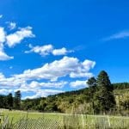
Kendal
In the photo named The Pretty Green Grass is shot at a unique angle making the grass blades look just as tall as the mountain
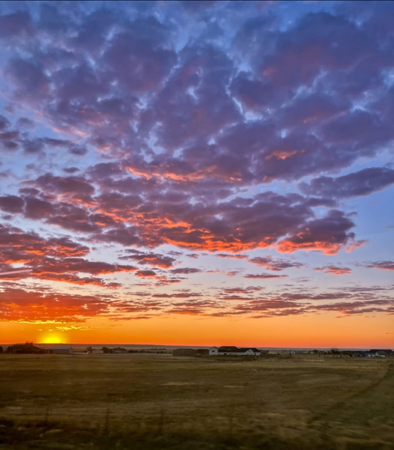
Sunrise in Hugo by Hannah

I love the colors in this photo and how the angle that the photo is taken at makes the clouds look closer than they are.

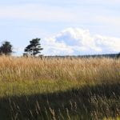
Grassy Grass By Oliver
I like how the photo shows movement and depth with the camera angle that the photo was taken at.

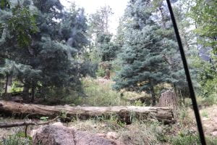
LOG by Jose

This photo shows a good use of leading lines and how the black line and the log causes the eyes to focus on the middle of the trees.

