Comments 3 Christian Adams Colon
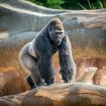
Eli
I love that the gorilla photo has a lot of contrast that makes the gorilla standout from the background.
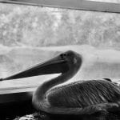
Holly
In the Candid Pelican photo, I like the use of the black and white the uses of Black and white makes the shape of the feathers standout.
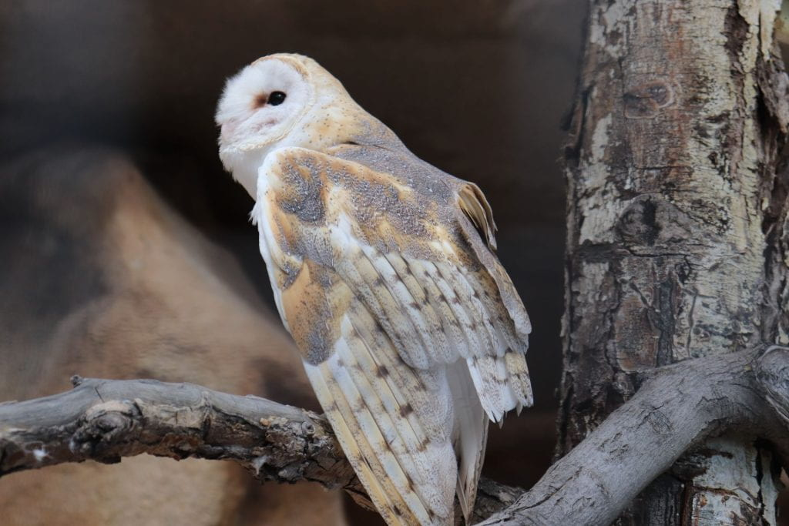
Oliver
I like the angle of the photo it makes the photo makes the owl pop out from the background by making it slightly blurred.
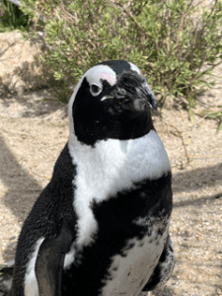
Sydnie
I like the angle of the photo it makes the penguin look defined and proper.

